Advance Computer network PCS223
Assignment-2
Suryansh Sharma 8025320099

- To capture and analyze ICMP packets (Ping request and reply)
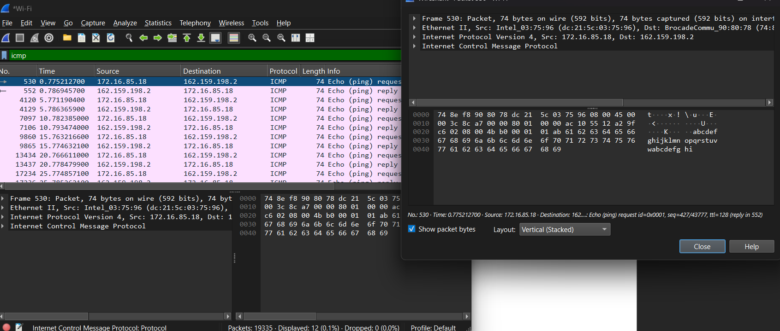
Observation
- Interface used: Wi-Fi
- Protocol: ICMP
- Type: Echo (Ping) Request
- Source IP address: 172.16.85.18
- Destination IP address: 162.159.198.2
- Packet length: 74 bytes

- To analyze TCP packets and observe the TCP three-way handshake
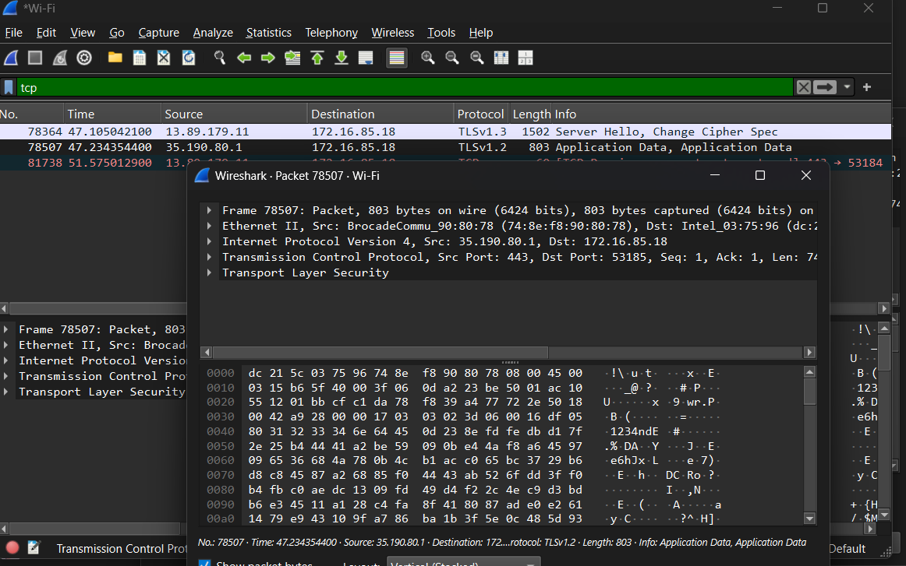
Observation
- Interface used: Wi-Fi
- Protocol: TCP
- Source IP address: 13.89.179.11
- Destination IP address: 172.16.85.18
- Source Port: 443
- Destination Port: 53184
- Flags observed: FIN, ACK
- Packet length: 60 bytes

- To capture and analyze UDP packets
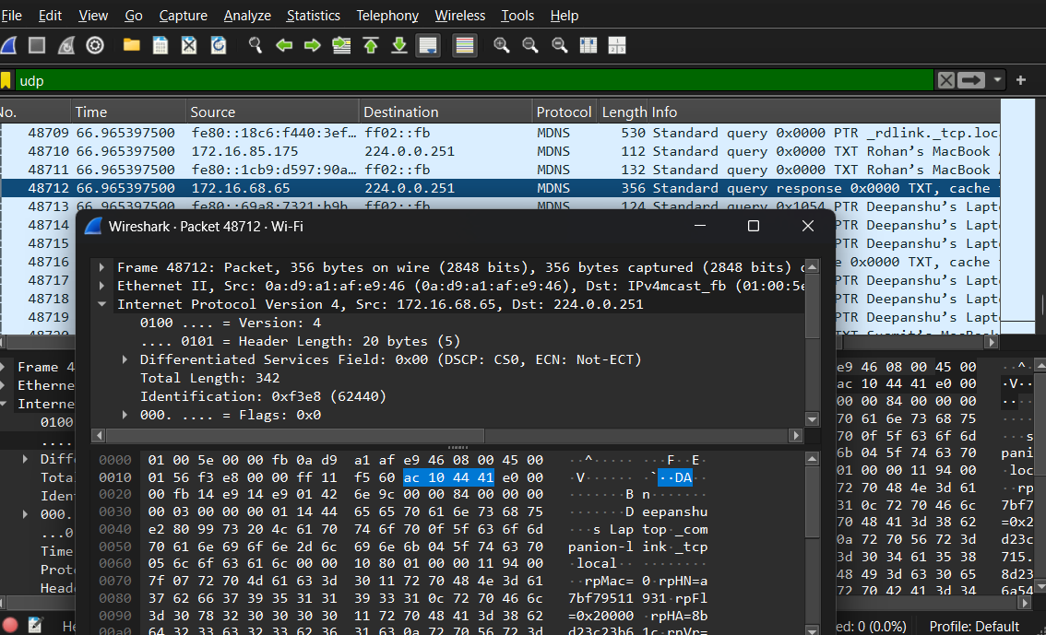
Observation (UDP Experiment)
- Interface used: Wi-Fi
- Protocol: UDP
- Source IP address: 172.16.68.65
- Destination IP address: 224.0.0.251
- Source Port: 5353
- Destination Port: 5353
- Packet length: 356 bytes
- Application layer protocol: DNS (mDNS)

- To capture and analyze DNS query and response packets
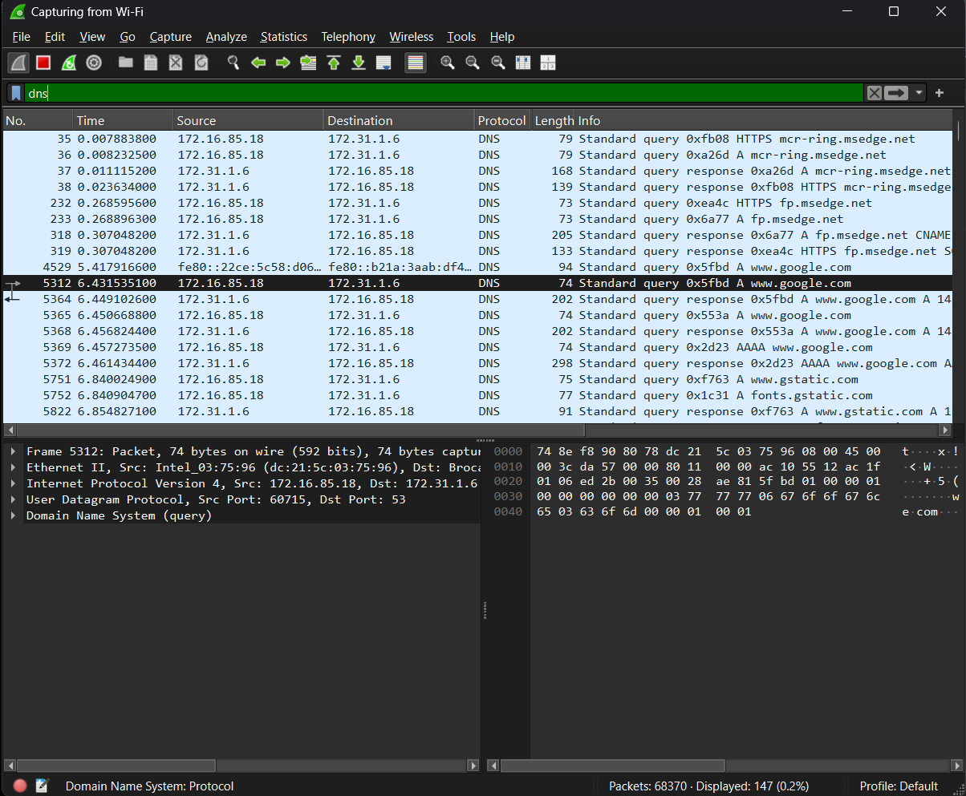
Observation
- Interface used: Wi-Fi
- Protocol: DNS
- Transport protocol: UDP
- Source IP address: 172.16.85.18
- Destination IP address: 172.31.1.6
- Source Port: 60715
- Destination Port: 53
- Query: www.google.com
- Packet length: 74 bytes

- To capture and analyze HTTP packets

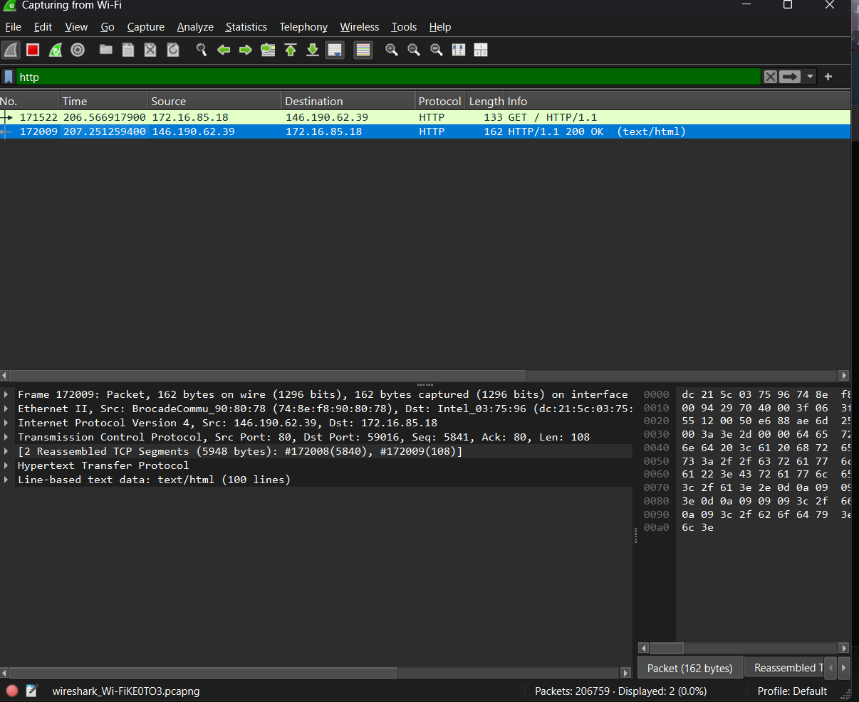

Observation
- Interface used: Wi-Fi
- Protocol: HTTP
- Transport protocol: TCP
- Source IP address: 172.16.85.18
- Destination IP address: 146.190.62.39
- Source Port: 59016
- Destination Port: 80
- Request Method: GET
- Response: HTTP/1.1 200 OK
- Content Type: text/html

- To analyze ARP request and reply packets

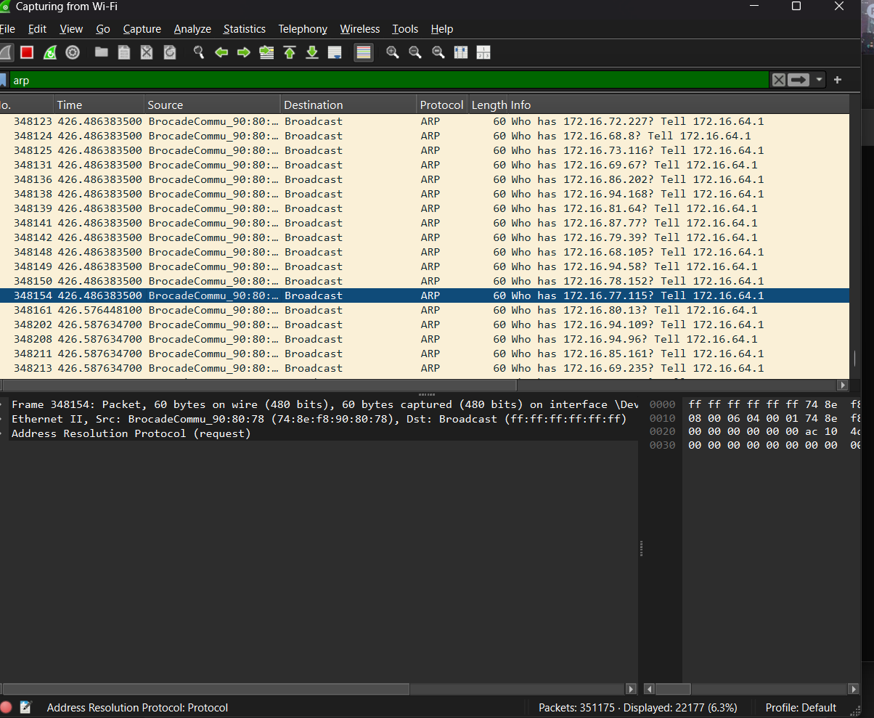

Observation
- Interface used: Wi-Fi
- Protocol: ARP
- Type: ARP Request
- Source MAC address: 74:8e:f8:90:80:78
- Destination MAC address: ff:ff:ff:ff:ff:ff (Broadcast)
- Query: Who has 172.16.77.115? Tell 172.16.64.1
- Packet length: 60 bytes

- To identify source and destination MAC and IP addresses in captured packets
- Interface used: Wi-Fi
- Source MAC address: 74:8e:f8:90:80:78
- Destination MAC address: ff:ff:ff:ff:ff:ff
- Source IP address: 172.16.64.1
- Destination IP address: 172.16.77.115

